TEST SCENARIO TEMPLATE

What is a Test Scenario?
A Scenario is any functionality that can be tested. It is also called Test Condition, or Test Possibility.
A set of test cases that ensure that the business process flows are tested from end to end. They may be independent tests or a series of tests that follow each other, each dependent on the output of the previous one.

Test Scenario should consist of the below:
- Scenario #/Name
I strongly recommend coming up with a numbering sequence (perhaps meshing with the use case numbering scheme in place) and also naming the test scenario something specific that will help differentiate it from the other test scenarios.
- Scenario Description
This should be narrative and explain the purpose of the tests, a brief overview of the test cases, and/or references to other related test scenarios.
- Version Control
It is particularly important when you have a large number of test scenarios to track when something was baselined and when subsequent modifications were made. You may want to tweak this to track approvals as well.
- Test Scripts
Simple list of test cases comprised in the test scenario.

- Use Case
Reference the related use case, if you are using them. I would suggest limiting a test scenario to cover only one use case and not more (though of course you may have more than one test scenario covering a specific use case).
- Test Components/Requirements
In this section list the technical and/or functional components being covered along with any requirement groups that are being tested. Do not list specific requirements here – that will be done in each test case. Listing components is very helpful if you’re assigning test cases to testers based on technical/functional component or you’re looking at a phased delivery of functionality to test (where components 1-3 are available on a specific date, but components 4-6 are not ready until a future date).
- User Groups:

List the target user group(s).

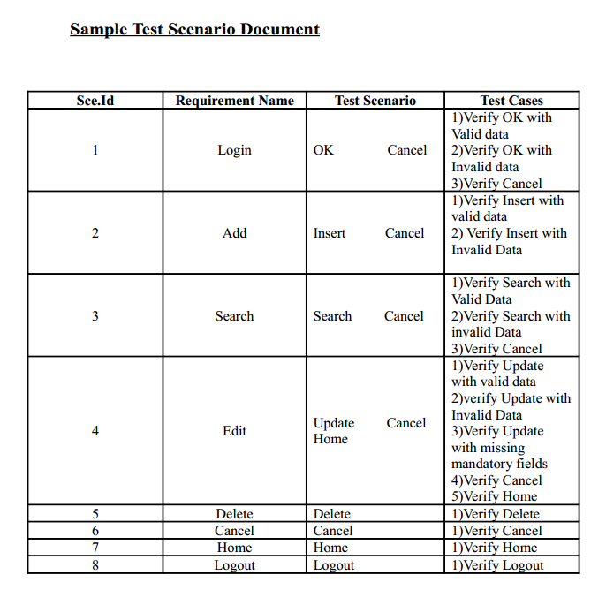

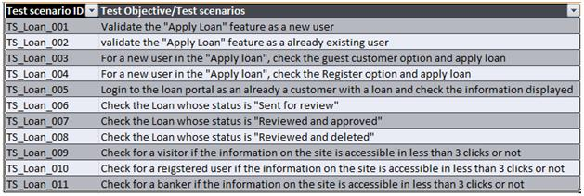
Few Pointers to remember:
- A new product is under development, we as a testing team are given design docs to write test cases for each feature.
- Before writing any test case, one should concentrate on various scenarios which the product will face when it will be at customers site.By doing this you are sure that very obvious things are not missed.
- Scenario writing should be given time, thorough review process should be followed. Because this would be forming the base for future test cases and testing.
- Scenario should be one liner and less descriptive. The intention here is not to provide details, but the specific idea of testing a particular case.

For e.g. if we have to write testing scenarios for a Login Screen (this is just an example, it has username password and submit cancel button)
Various scenarios to test the Login screen can be:
1. Different combinations of username and passwords
2. User unable to log because of various reasons
3. Incorrect combination of username and password
Also, if a feature like Automatic Updates of a product is to be tested, the scenarios can be:
1. Check for manual updates option
2. Scheduling auto updates
3. Updates in slow bandwidth
4. Updates when network failure is intermittent/disconnected
5. Other updates are in progress
6. Pause/resume, stop/restart functionality

Q) Difference between Test case and Test scenario:

Test case consist of set of input values, execution precondition, excepted Results and executed post condition, developed to cover certain test Condition. While Test scenario is nothing but test procedure.
A Test Scenarios have one to many relation with Test case, Means A scenario have multiple test case. Every time we have write test cases for test scenario. So while starting testing first prepare test scenarios then create different-2 test cases for each scenario.
Test cases are derived (or written) from test scenario. The scenarios are derived from use cases.
Test Scenario represents a series of actions that are associated together. While test Case represents a single (low level) action by the user.
Scenario is thread of operations whereas Test cases are set of input and output given to the System.
→For example:
Checking the functionality of Login button is Test scenario and
Test Cases for this Test Scenario are:
1. Click the button without entering user name and password.
2. Click the button only entering User name.
3. Click the button while entering wrong user name and wrong password.
Etc…
In short,
Test Scenario is ‘What to be tested’ and Test Case is ‘How to be tested’.

